Blockmodels

Based on Wasserman and Faust (1994) Chapter 10

Blockmodels represent hypothesized relations (ties) among actors occupying structurally equivalent positions (blocks) in networks (see W&F Chap 9 on SE).

Blockmodel – a partition of the set of g actors, in one or more relational networks, into B discrete positions, with permuted and blocked matrices showing the presence or absence of ties within and between positions for each type of relation.

Image – a reduced BxB blockmodel matrix whose 0-1 entries show the presence and absence of ties among the B positions

oneblock (bond): image entry = 1, a tie from row block to column block

zeroblock: image entry = 0, no tie from row to column blocks

Because several actors may jointly occupy a position, the intrablock relations in blockmodels and images have different implications than the self-ties in actor-based matrices, which are usually ignored as undefined.

In a world trade blockmodel image, a main-diagonal entry shows whether nations occupying that block exchange goods among themselves. An off-diagonal entry shows the trade flows between the nations occupying different structurally equivalent positions.

BUILDING BLOCKS

A blockmodel could be constructed theoretically, by an analyst imposing the positions she believes to represent structurally equivalent blocks. For example, sort the employees of different departments into separate blocks. Or apply a method, such as CONCOR, to identify the s.e. positions from the empirical relations in the data. In both approaches, the resulting blockmodel is a permuted and partitioned matrix that locates the actors occupying a position in adjacent rows and columns.

Unfortunately, the positions in a blocked matrix rarely exhibit perfect (strict) structural equivalence: a submatrix filled with either all 1s (“fat fit”) or all 0s (“lean fit”), meaning that all block actors have identical relations, either with one another or with every actor in another block. Blockmodels of real social data typically find positions that contain mixtures of 1s and 0s. The analyst must then decide on some criterion for assigning either 0 or 1 to each cell of the blockmodel image.

For a binary network, most blockmodelers use an α density criterion to determine the image matrix:

- If the intra- or interblock proportion of direct ties is above the α density, recode that block = 1 in the image matrix.

- If the density of direct ties falls below the specified cutoff density, recode that image block = 0.

For a network of valued relations, an analyst might recode the image according to whether each block’s density is above or below the network mean density.

Suppose a 4x4 blocking finds these submatrix proportions, where the overall mean network density = 0.30:

 | Block I | Block II | Block III | Block IV
Block I | 0.70 | 0.48 | 0.27 | 0.19
Block II | 0.33 | 0.40 | 0.31 | 0.11
Block III | 0.37 | 0.30 | 0.29 | 0.08
Block IV | 0.32 | 0.29 | 0.02 | 0.12

Then using 0.30 as the α density criterion, the blockmodel image is:

1 | 1 | 0 | 0
1 | 1 | 1 | 0
1 | 1 | 0 | 0
1 | 0 | 0 | 0

The cells in red draw attention to three positions whose densities are just above or just below the α cutoff. Increasing the α criterion (e.g., to 0.40) or lowering it (e.g., to 0.20) would produce a much different blockmodel images with fewer or more oneblocks, respectively.

BLOCKMODELS & IMAGES of MULTIPLEX RELATIONS

A blockmodel that simultaneously blocks two or more relations by partitioning actors into structurally equivalent positions may produce distinctive images for each matrix. This example blocks two asymmetric networks -- money and information exchange -- among 10 Indianapolis organizations (Knoke and Kuklinski 1982:44).

First, import both matrices into UCINET and create two transposes. Use “Data/Join” to stack all four matrices into a single 40x10 data array. Next, use “Tools/Similarities” to compute the matrix of correlations among pairs of columns:

1 2 3 4 5 6 7 8 9 10
County Counci Educat Indust Mayor WRO Newspa United Welfar Westen
------ ------ ------ ------ ------ ------ ------ ------ ------ ------
1 County 1.000 0.142 0.150 0.451 0.278 0.105 0.298 0.257 0.341 0.107
2 Council 0.142 1.000 -0.061 0.142 0.404 0.350 0.297 0.143 0.142 0.207
3 Education 0.150 -0.061 1.000 0.043 -0.041 -0.102 0.316 0.375 0.471 0.171
4 Industry 0.451 0.142 0.043 1.000 0.383 0.105 0.298 0.150 0.341 0.358
5 Mayor 0.278 0.404 -0.041 0.383 1.000 0.317 0.323 -0.041 0.068 0.153
6 WRO 0.105 0.350 -0.102 0.105 0.317 1.000 -0.086 0.068 -0.070 0.419
7 Newspaper 0.298 0.297 0.316 0.298 0.323 -0.086 1.000 0.000 0.406 0.077
8 UnitedWay 0.257 0.143 0.375 0.150 -0.041 0.068 0.000 1.000 0.257 0.293
9 Welfare 0.341 0.142 0.471 0.341 0.068 -0.070 0.406 0.257 1.000 0.358
10 Westend 0.107 0.207 0.171 0.358 0.153 0.419 0.077 0.293 0.358 1.000

Then use CONCOR on the saved correlation matrix to find a 2-level partition (4 blocks); answer “YES” to “input is corr mat”. Here’s the cluster diagram showing which orgs belong to which block:

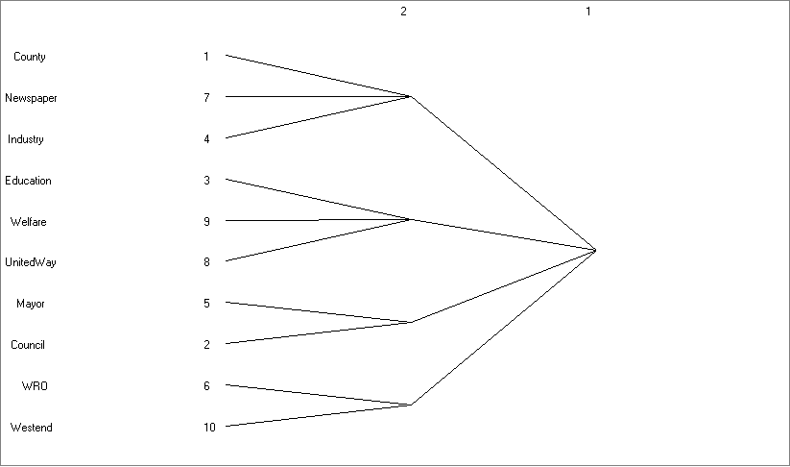

Use “Transform/Block” to impose two separate blockmodels on the original info and money matrices, according to the partition results above. Tell this program which actors belong to which blocks by entering a sequence of numbers, into the “Row partition/blocking (if any)” and “Column partition/blocking” lines, that correspond to the block location of each actor. Indianapolis orgs 1-10 must be sorted into these 4 blocks: 1 3 2 1 3 4 1 2 2 4

Imported from Money.txt
1
1 7 4 3 9 8 5 2 6 0
C N I E W U M C W W
---------------------------
1 County | | 1 1 1 | 1 | 1 |
7 Newspaper | | 1 | 1 | |
4 Industry | 1 | 1 1 1 | 1 | |
-----------------------------
3 Education | | 1 | | |
9 Welfare | | 1 1 | | |
8 UnitedWay | | 1 | | 1 |
-----------------------------
5 Mayor | | 1 1 1 | 1 | |
2 Council | | 1 | | |
-----------------------------
6 WRO | | | | |
10 Westend | | | | |
----------------------------

Reduced BlockMatrix
1 2 3 4
----- ----- ----- -----
1 0.167 0.778 0.500 0.167
2 0.000 0.667 0.000 0.167
3 0.000 0.667 0.500 0.000
4 0.000 0.000 0.000 0.000

Finally, if you save the Reduced BlockMatrix densities (by typing a name into the “(Output) Reduced image dataset” line), you can then obtain its image with the “Transform/Dichotomize” program. For “Cut-Off Operator” choose “GE - Greater Than or Equal” and for “Cut-Off Value” set the α density criterion at 0.50. The resulting money exchange image is:

Rule: y(i,j) = 1 if x(i,j) >= 0.50, and 0 otherwise.
Reduced BlockMatrix
1 2 3 4
- - - -
1 0 1 1 0
2 0 1 0 0
3 0 1 1 0
4 0 0 0 0

The same procedures applied to the denser Indianapolis information matrix yields different results, with four “fat fit” and two “lean fit” blocks:

Imported from Information.txt
1
1 7 4 3 9 8 5 2 6 0
C N I E W U M C W W
---------------------------
1 County | 1 | 1 | 1 1 | |
7 Newspaper | 1 | | 1 1 | |
4 Industry | 1 1 | | 1 1 | |
-----------------------------
3 Education | 1 1 | | 1 1 | 1 1 |
9 Welfare | 1 | | 1 1 | |
8 UnitedWay | 1 1 1 | 1 | 1 1 | |
-----------------------------
5 Mayor | 1 1 1 | 1 1 1 | 1 | 1 |
2 Council | 1 1 1 | 1 1 1 | 1 | |
-----------------------------
6 WRO | 1 | 1 1 | | |
10 Westend | 1 1 | 1 | 1 1 | |
----------------------------

Reduced BlockMatrix
1 2 3 4
----- ----- ----- -----
1 0.667 0.111 1.000 0.000
2 0.667 0.167 1.000 0.333
3 1.000 1.000 1.000 0.250
4 0.500 0.500 0.500 0.000

Rule: y(i,j) = 1 if x(i,j) >= 0.50, and 0 otherwise.
Reduced BlockMatrix
1 2 3 4
- - - -
1 1 0 1 0
2 1 0 1 0
3 1 1 1 0
4 1 1 1 0

Analogous methods apply to blockmodeling valued-relations networks, but might use a maximum value, mean value, or some other cut-off criterion to recode continuous scores into the 0-1 entries of an image (p. 406-8).

Blockmodel Interpretation

Blockmodels are theoretical or empirical hypotheses about structural relations in a network, which refer to positions not to individual actors. W&F discuss three ways to interpret a blockmodel or its image:

- Validation using actor attributes: Look for common characteristics of actors within a block that set them apart for other blocks. Does the position comprise an implicit “type of actor” to which you could fix a meaningful label? In international trade, are nations clustered by geography and/or level of economic development?

One interpretation of the contrasting Indianapolis money & information exchange blockmodels is that the positions are differentiated by the organizations’ primary functions or goals. The main money recipient is the service-provider position {Education, Welfare, United Way}, while the main information targets are the elite position {County, Industry, Newspaper} and city government position {Mayor, City Council}. The neighborhood position {Welfare Rights Org and Westend} receives neither money nor information from any position, although it claims to send information to the other three.

- Describe individual positions: Examine the patterns of interblock relations for clues about the social roles each position plays. Some blocks may be generic types identified by their in- and outdegree ratios (isolates, receivers, transmitters, and carriers/ordinaries), as well as by their within-block connections (see typologies developed by Burt [1976], Richards [1989], and Marsden [1989]). Other positions might be better described by interpreting the substantive contents of their multiplex relations. The Indianapolis city government position is both a money and information provider, while the power elite block is mainly a money supplier.

- Image Matrices: By ignoring the individual actors and considering only the entire configuration of ties among positions displayed in the images, researchers may be able to distinguish some formal properties. White, Boorman and Breiger (1976) described 10 distinct arrangements of 0s and 1s for two-block images (W&F p. 421). Three-position images have 104 distinct image matrices; W&F apply intriguing labels to several “ideal” images (center-periphery, hierarchy, transitive).

No mechanical, fool-proof method exists for interpreting blockmodels and images. As usual in network research, analysts must apply all their substantive knowledge about the system to make imaginative and insightful interpretations.

